INFORMED CONSENT

PATIENT NAME

Clinic Name: Aligned For Health Chiropractic

Doctor's Name: Dr. Tena Thompson

Address: 739 South Main Street, Viroqua, WI 54665

Phone:(608) 637-6577 Fax: (608) 637-7799

The primary treatment used by Doctor of Chiropractic is the spinal manipulation, sometimes called spinal adjustment.

- The nature of the chiropractic adjustment.
I will use my hands or a mechanical instrument upon your body in such a way as to move your joints. That may cause an audible "pop" or "click," much as you have experienced when you "crack" your knuckles. You may feel or sense movement.

- The material risks inherent in chiropractic adjustment.
As with any healthcare procedure, there are certain complications, which may arise during chiropractic manipulation. Those complications include fractures, disc injuries, dislocations, muscle strain, Horner's syndrome, diaphragmatic paralysis, cervical myelopathy and costovertebral strains and separations. Some types of manipulation of the neck have been associated with injuries to the arteries in the neck leading to or contributing to serious complications including stroke. Some patients will feel some stiffness and soreness following the first few days of treatment.

- The probability of those risks occurring.
Fractures are rare occurrences and generally result from some underlying weakness of the bone, which we check for during the taking of your history and during examination and X-ray. Stroke has been the subject of tremendous disagreement within and without the profession with one prominent authority saying that there is at most a one-in-a-million chance of such an outcome. Since even that risk should be avoided if possible, we employ tests in our examination which are designed to identify if you may be susceptible to that kind of injury. The other complications are also generally described as "rare."

- The availability and nature of other treatment options. Other treatment options for your condition include:

- Self-administered, over-the-counter analgesics and rest
- Medical care with prescription drugs such as anti-inflammatories, muscle relaxants and painkillers.
⬥ Hospitalization with traction
- Surgery

- The material risks inherent in such options and the probability of such risks occurring include:

- Overuse of over-the-counter medications produces undesirable side effects. If complete rest is impractical, premature return to work and household chores may aggravate the condition and extend the recovery time. The probability of such complications arising is dependent upon the patient's general health, severity of the patient's discomfort, his pain tolerance and self-discipline in not abusing the medicine. Professional literature describes highly undesirable effects from long term use of over-the-counter medicines.

- Prescription muscle relaxants and painkillers can produce undesirable side effects and patient dependence. The risk of such complications arising is dependent upon the patient's general health, severity of the patient's discomfort, his pain tolerance, self-discipline in not abusing the medicine and proper professional supervision. Such medications generally entail very significant risks - some with rather high probabilities.

- Hospitalization in conjunction with other care bears the additional risk of exposure to communicable disease, iatrogenic (doctor induced) mishap and expense. The probability of iatrogenic mishap is remote, expense is certain, exposure to communicable disease is likely with adverse result from such exposure dependent upon unknown variables.

- The risks inherent in surgery include adverse reaction to anesthesia, iatrogenic (doctor induced) mis- hap, all those of hospitalization and an extended convalescent period. The probability of those risks occurring varies according to many factors.

- The risks and dangers attendant to remaining untreated.
Remaining untreated allows the formation of adhesions and reduces mobility which sets up a pain reaction further reducing mobility. Over time, this process may complicate treatment making it more difficult to treat and less effective the longer it is postponed. The probability that non-treatment will complicate a later rehabilitation is very high.

DO NOT SIGN UNTIL YOU HAVE READ AND UNDERSTAND THE ABOVE.
I have read or have had read to me the above explanation of the chiropractic adjustment and related treatment. I have discussed it with Dr. Tena Thompson and have had my questions answered to my satisfaction. By signing below, I state that I have weighed the risks involved in undergoing treatment and have myself decided that it is in my best interest to undergo the treatment recommended. Having been informed of the risks, I hereby give my consent to that treatment.

Date: __________________________________

________________________________________
Printed Name
________________________________________
Signature

________________________________________
Signature of Parent or Guardian (if a minor)

Chiropractic Case History/Patient Information

Date: FOR STAFF USE ONLY

Name: _______________________________________ Date of Birth: _______________________ Age: _____________

Address: ____________________________ City: _______________________ State: __________ Zip Code:___________

Cell# _____________________ Home# _______________________Email: _____________________________________

REMINDER CALL PREFERENCE: ☐TEXT ☐EMAIL ☐PHONE CALL

☐Married ☐Single ☐Widowed ☐Divorced ☐Separated

Nearest Relative and Phone#: _____________________________________________________________________

Occupation: _________________
Patient # FOR STAFF USE ONLY

Employer: ___________________
Doctor: FOR STAFF USE ONLY

Work#: _____________________

Employer Address: _________________________________________________________________________________

Purpose of this Appointment: _________________________________________________________________________

Have you had this before? ☐YES ☐NO

Have you seen a Medical Doctor, or a Doctor of Chiropractic for this condition? ☐YES ☐NO

If yes, please explain: _______________________________________________________________________

Insured’s Name: ____________________________________________ Insured’s DOB: __________________

Insured’s Employer: __________________________________________________________________________

Please circle any/all insurance coverage that may be applicable:
Major Medical Worker’s Compensation Medicaid
Medicare Auto Accident Other: ________________________________________________
Name of Primary Insurance: _________________________________________________________________________
Name of Secondary Insurance (if any): _________________________________________________________________

AUTHORIZATION AND RELEASE: I authorize payment of insurance benefits directly to the chiropractor or chiropractic office. I authorize the doctor to release all information necessary to communicate with personal physicians and other healthcare providers and payors and to secure the payment of benefits. I understand that I am responsible for all costs of chiropractic care, regardless of insurance coverage. I also understand that if I suspend or terminate my schedule of care as determined by my treating doctor, any fees for professional services will be immediately due and payable. I understand that interest is charged on overdue accounts at the annual rate of 16%.
The patient understands and agrees to allow this chiropractic office to use their Patient Health Information for the purpose of treatment, payment, healthcare operations, and coordination of care. We want you to know how your Patient Health Information is going to be used in this office and your rights concerning those records. If you would like to have a more detailed account of our policies and procedures concerning the privacy of your Patient Health Information, we encourage you to read the HIPAA NOTICE that is available to you at the front desk before signing this consent. If there is anyone you do not want to receive your medical records, please inform our office.
Patient Signature: __________________________________________________ Date: ________________________
Guardian Signature: ________________________________________________ Date: ________________________

Complaint #1
1. What is your MAIN complaint? _____________________
2. When did you first notice this problem and what were you doing? ___________________________________________ _________________________________________________

3. What does this keep you from doing?
_________________________________________________
4. Rate your symptoms: ______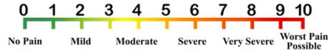
0 1 2 3 4 5 6 7 8 9 10

No Mild Moderate Severe Very Severe Worst Pain Pain Possible
5. Has it gotten worse? (Check ALL that apply)
☐Same ☐Better ☐Gradually Worse
6. How frequent is the condition?
☐Intermittent ☐Night Only
☐Constant ☐Daily
7. Describe the pain. (Check ALL that apply)
☐Sharp ☐Dull ☐Achy ☐Numbness ☐Tingling ☐Burning ☐Stabbing ☐Other: ___________________________
8. Is there anything you can do to RELIEVE the problem?
☐Yes ☐NO
- If YES, please describe: _______________________________________________
- If NO, what have you tried that has not worked?
_______________________________________________
9. What makes the problem WORSE? (Check ALL that apply)
☐Standing ☐Sitting ☐Lying
☐Bending ☐Lifting ☐Twisting

10. Is the condition due to injury or sickness arising out of:
☐Employment ☐Auto ☐Other Accident
18.Please select activities you are currently experiencing problems with:

☐Vision ☐Taste ☐Smell ☐Eating ☐Hearing ☐Insomnia ☐Dressing ☐Reading ☐Typing ☐Writing ☐Grasping ☐Using the toilet☐Standing ☐Leaning ☐Walking ☐Stooping ☐Squatting ☐Loss of sexual drive ☐Bending ☐Twisting ☐Carrying ☐Lifting ☐Pushing ☐Restful sleep ☐Sitting ☐Driving ☐Sports ☐Exercising ☐Reclining ☐Holding
☐Grooming ☐Pinching ☐Kneeling ☐Reaching ☐Nervous ☐Tactile feeling ☐Bathing ☐Concentration

Doctor’s Signature_______________________________________ Date___________________________
DETAILS 2

11. Are you, or is there a possibility you may be pregnant?
☐YES ☐NO ☐Uncertain
12. Have you lost time from work? ☐ YES ☐NO
13. Can you perform physical work activities? ☐YES ☐NO
14. If no, because of: ☐PAIN ☐WEAKNESS ☐STRESS
15. Can you go to sleep without problems? ☐YES ☐NO
16. Do you awaken because of pain? ☐YES ☐NO
17. Did you have sleep problems before? ☐YES ☐NO

Complaint #2
1. What is your SECONDARY complaint? __________________
2. When did you first notice this problem and what were you doing? ___________________________________________ _________________________________________________

3. What does this keep you from doing?
_________________________________________________
4. Rate your symptoms: ______
0 1 2 3 4 5 6 7 8 9 10

No Mild Moderate Severe Very Severe Worst Pain Pain Possible
5. Has it gotten worse? (Check ALL that apply)
☐Same ☐Better ☐Gradually Worse
6. How frequent is the condition?
☐Intermittent ☐Night Only
☐Constant ☐Daily
7. Describe the pain. (Check ALL that apply)
☐Sharp ☐Dull ☐Achy ☐Numbness ☐Tingling ☐Burning ☐Stabbing ☐Other: ___________________________
8. Is there anything you can do to RELIEVE the problem?
☐Yes ☐NO
- If YES, please describe: _______________________________________________
- If NO, what have you tried that has not worked?
_______________________________________________
9. What makes the problem WORSE? (Check ALL that apply)
☐Standing ☐Sitting ☐Lying
☐Bending ☐Lifting ☐Twisting

10. Is the condition due to injury or sickness arising out of:
☐Employment ☐Auto ☐Other Accident

History
Patient Name: _____________________________ Date: _______________
Family/Personal Medical History: Please review the below listed diseases and conditions and indicate those that are current health problems of the identified person listed. Leave blank those spaces that do not apply.

Condition | Mother | Father | Brothers | Sisters | Children n | Spouse | ME
Allergies/Asthma
Anxiety
Arthritis
Back Trouble/Disc Trouble
Birth Defects
Bladder or Urinary Problems
Blood Disorder
Breast lumps/soreness
Bursitis
Cancer
Cardiovascular Problems
Chest Pain
Constipation
Depression/Mental Illness
Dermatitis/Eczema/Rash
Diabetes
Difficulty Swallowing
Digestive Problems
Dizziness or Fainting
Others:

Condition | Mother | Father | Brothers | Sisters | Children | Spouse | ME
Excessive Thirst
General Fatigue
Gallbladder/Liver Trouble
Headaches/Migraines
Heart Attack
Heart Problems
Heartburn/Ulcer
Hepatitis
High Blood Pressure
High Cholesterol
Kidney problems
Lung/Breathing Problems
Neuropathy
Osteoporosis
Sleep Trouble/Disorder
Swelling or stiff Joint(s)
Scoliosis
Thyroid Disease
Vision or Hearing problems
Other:

Are there any other unrelated health problems? ☐ Yes ☐No If Yes, please describe: _____________________________________ ____________________________________________________________________________________________________________ Have you had any broken bones, major accidents, or serious injuries? ☐ Yes ☐No If Yes, please list the dates and the injuries: ____________________________________________________________________________________________________________
List any procedures/surgeries you have had:________________________________________________________________________________
List your Allergies:_____________________________________________________________________________________________________
Social History: ☐Married ☐Single ☐Widowed ☐Divorced ☐Separated
How many children do you have? _______ Are you, or is there a possibility you may be pregnant? ☐YES ☐NO ☐Uncertain
Do you use: ☐Tobacco ☐Alcohol ☐Coffee Have you had: ☐ Measles ☐ Mumps ☐ Chicken Pox
Smoking Status: ☐Every Day ☐ Some days ☐Former Smoker ☐ Never Smoked
Smoking start date: ______________ Smoking end date: _______________

Medication: Please list ALL vitamin/supplement, birth control, and other medications you are currently taking:
_____________________________________________________________________________________________________________________
_____________________________________________________________________________________________________________________

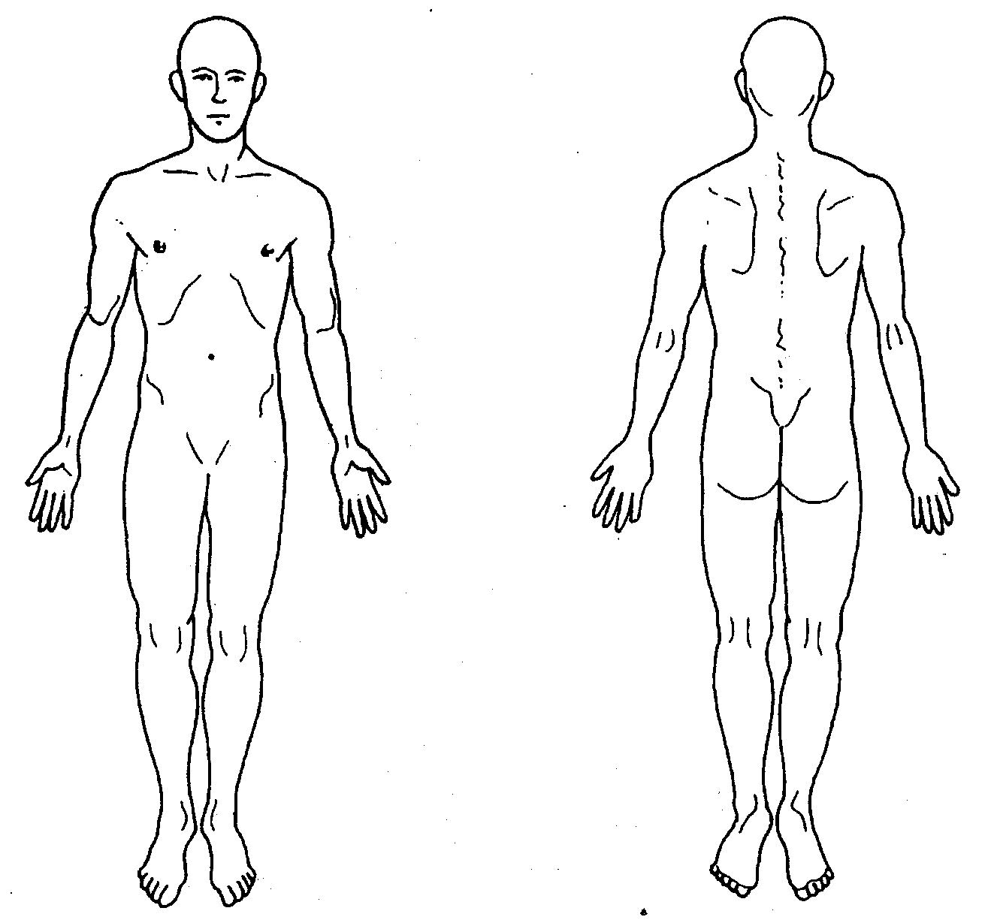
Patient #: ___________________
Pain Drawing

Name:_____________________________________ Date:____________________________

Date of Birth: _______________________________ Examiner: ________________________

TELL US WHERE YOU HURT.
Please read carefully:
Mark the areas on your body where you feel your pain. Include all affected areas. Mark areas of radiation. If your pain radiates, draw an arrow from where it starts to where it stops. Please extend the arrow as far as the pain travels. Use the appropriate symbol(s) listed below.

Ache > > > > > Numbness = = = = = = Pins & Needles o o o o
Burning x x x x Stabbing / / / / / Throbbing ~ ~ ~ ~ ~ ~
Office Use Only
1
4-5
>5

